Disconnect Global Protect (GP) VPN Before starting script
Standard Operating Procedure
Running the MASH CI RSS Monitoring End-to-End Pipeline
Run_EndToEnd.py — RSS Extraction → Link Dedup → AI Triage

1. Purpose
This SOP explains how to run the automated RSS monitoring pipeline for MASH CI. No coding knowledge is required. The tool automatically:
- Pulls the latest news, clinical trial updates, company alerts, regulatory notices and media coverage from all configured RSS feeds.
- Removes duplicate articles and resolves Google Alert redirect links back to the real source URL.
- Runs each article through an AI triage step that classifies and summarizes relevance.
- Runs surviving articles through a provenance check and drafts a Morning/Evening Update (Word doc and/or Outlook draft) -- this step (Stage 4) is currently answered “No” by default, see Step 2 below.
The end result is a single, triaged Excel report ready for review.

2. Before You Start (One-Time Setup)

2.1 Install Python
If Python is not already installed on your laptop:
- Download Python 3.10 or later from https://www.python.org/downloads/
- During installation, tick the checkbox “Add Python to PATH” before clicking Install.
Skip if already done: If someone in IT has already set up Python on your machine, or you have run this tool before, skip to section 2.2.

2.2 Install the Required Python Packages
Open Command Prompt (search “cmd” in the Windows Start menu) and run the single command below. This only needs to be done once per laptop:
pip install pandas openpyxl feedparser requests dnspython curl_cffi parallel-web
What each package is for:
- pandas — builds and merges the Excel reports
- openpyxl — reads/writes the .xlsx report files and formatting
- feedparser — reads RSS/OPML feed content
- requests — downloads feed and article content
- dnspython — DNS fallback so regulatory feeds (e.g. Japan PMDA, Australia TGA) resolve reliably on the corporate network
- curl_cffi — resolves certain protected/anti-bot article links during dedup
- parallel-web — connects to the Parallel AI Task Group API used for the triage stage

2.3 Add the Parallel AI API Key
The AI triage stage (Stage 3) needs an API key to run:
- Open the Scripts folder inside the workflow folder.
- Open the file named “Parallel API Key.txt” in Notepad.
- Paste your Parallel API key in (no quotes, no extra spaces), then save and close the file.
Important: If this file is left empty, Stage 1 and 2 (extraction and dedup) will still work, but Stage 3 (AI triage) will fail. The tool will warn you about this before it starts.

3. Running the Pipeline

Step 1 — Launch the tool
Go to the Scripts folder and double-click:
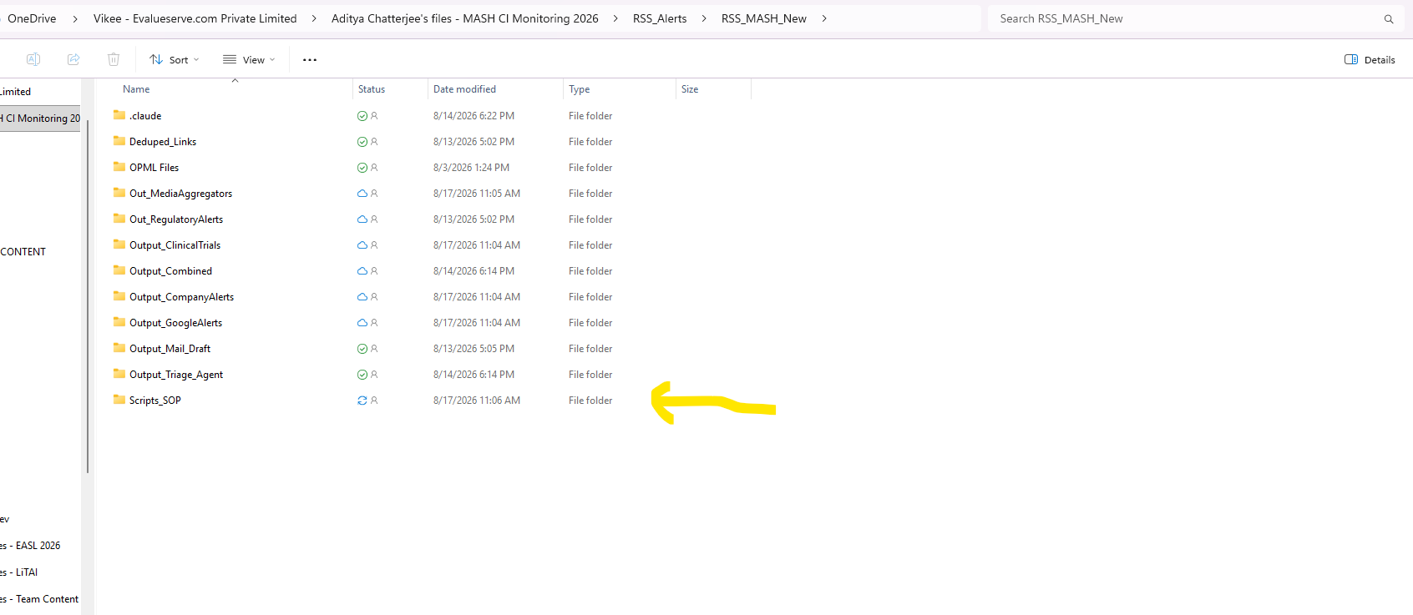
Run_EndToEnd.py
A black command-window will open. This is normal — it is simply showing you the tool's progress. Do not close it while it is running.

Step 2 — Decide on Stage 4 (provenance check + drafting)
Immediately after launch, before anything else, you will see:
Proceed with the provenance check and drafting step (Stage 4) once triage finishes? (y/n, default y):
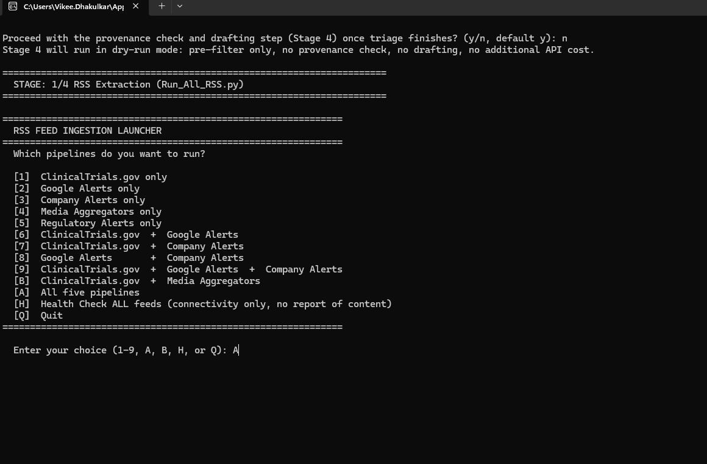
CURRENT GUIDANCE: type “n” and press Enter. Stage 4 (provenance check + AI drafting of the Morning/Evening Update) should stay OFF for now -- an optimization pass on Stage 4 is still pending, and the Parallel AI credit budget for the provenance-check call needs to be reviewed before it is run routinely. Answering “n” runs Stage 4 in dry-run mode: it still does the free pre-filter step, but skips the paid provenance check and drafting call entirely, so no extra API cost is incurred.
Do not answer “y” (or accept the default) unless you have been told the Stage 4 optimization and budget review are complete. If you answer “y” you will also be asked whether to create a Word document, an Outlook draft, or both.
Equivalent for a batch/unattended run: pass --skip-mail-draft on the command line to stop after Stage 3 and skip Stage 4's prompt entirely.

Step 3 — Confirm the API key warning (if shown)
If “Parallel API Key.txt” is empty, you will see a warning on screen. Type “y” and press Enter only if you deliberately want to run extraction and dedup without the AI triage step. Otherwise, close the window, add your key (Section 2.3), and start again.

Step 4 — Choose which RSS pipelines to run
The tool will show a menu like this:
Key | What it runs
1 | ClinicalTrials.gov only
2 | Google Alerts only
3 | Company Alerts only
4 | Media Aggregators only
5 | Regulatory Alerts only
6–9 | Various combinations of the above
A | All five pipelines (recommended for a full run)
H | Health check only — tests feed connectivity, does not pull articles
Q | Quit without running anything

Type the letter/number for what you want and press Enter. For a normal full run, type A and press Enter.

Step 5 — Enter a date range (optional)
Next you will be asked for a START date and an END date, for example:
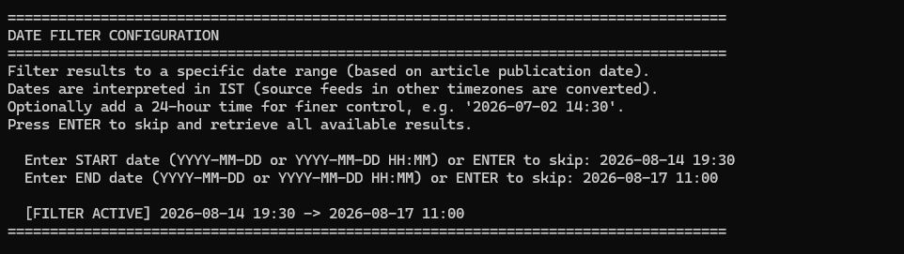
Enter START date (YYYY-MM-DD or YYYY-MM-DD HH:MM) or ENTER to skip:
Enter END date (YYYY-MM-DD or YYYY-MM-DD HH:MM) or ENTER to skip:
- To only pull articles published in a specific window, type a date like 2026-07-01 and press Enter for each prompt.
- To pull everything available with no date filter, just press Enter (leave blank) at both prompts.

Step 6 — Let it run
From here everything is automatic — no further input is required. You will see three stages run one after another in the same window:
Stage | What happens | Typical output folder
1. RSS Extraction | Pulls articles from every selected feed and merges them into one combined report | Output_Combined
2. Link Dedup | Resolves Google redirect links and removes duplicate articles | Deduped_Links
3. AI Triage | Sends each article through the Parallel AI Task Group API for classification/summary | Output_Triage_Agent
4. Provenance Check + Mail Drafting | OFF by default (current guidance: answer “n” at the Stage 2 prompt). When enabled, checks surviving articles for prior publication, then drafts a Morning/Evening Update via the Parallel AI API | Output_Mail_Draft

Depending on the number of pipelines chosen and article volume, a full run typically takes anywhere from a few minutes to 20+ minutes.

Step 7 — Run complete
When finished, the window prints a summary similar to:
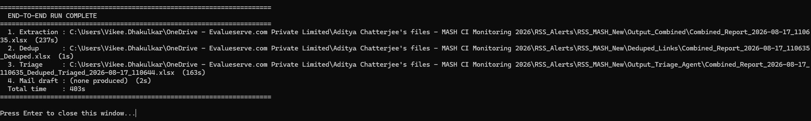
END-TO-END RUN COMPLETE
1. Extraction : Output_Combined\Combined_Report_...xlsx
2. Dedup : Deduped_Links\..._Deduped.xlsx
3. Triage : Output_Triage_Agent\..._Triaged_...xlsx
Total time : ...s
4. Mail draft : Output_Mail_Draft\..._Update_...docx (or 'none produced' if Stage 4 was skipped/answered No)
Press Enter to close the window. Your final, triaged Excel report is the file listed next to “3. Triage” — open it from the Output_Triage_Agent folder.

4. Where to Find Your Reports
Folder | Contains
Output_Combined | Raw merged RSS extraction, before dedup/triage
Deduped_Links | De-duplicated article list with real (resolved) source URLs
Output_Triage_Agent | FINAL report — AI-triaged and classified articles (use this one)
Output_Mail_Draft | Stage 4 output only (currently off by default) -- Word doc / Outlook draft of the Morning or Evening Update, plus a *_Combined_Review.xlsx audit trail

All three folders sit in the main workflow folder, one level above the Scripts folder.

5. Troubleshooting
Symptom | What to do
Window flashes and closes immediately | Right-click Run_EndToEnd.py → Open with → Python. If Python is not listed, reinstall Python and tick “Add to PATH”.
“ModuleNotFoundError” for any package | Re-run the pip install command in Section 2.2 — a package failed to install or was skipped.
Stage 3 (triage) fails immediately | Check that “Parallel API Key.txt” in the Scripts folder contains a valid key with no extra spaces or line breaks.
“No new Combined_Report produced” | No pipeline was selected, or no articles matched your date range. Re-run and choose “A” with a wider/blank date range.
Some regulatory feeds (Japan/Australia) time out | Usually transient network/DNS issues; re-run. If persistent, contact IT to confirm outbound access to those feed domains.

6. Quick Reference Card
What | How
One-time install | pip install pandas openpyxl feedparser requests dnspython curl_cffi parallel-web
Add API key | Paste key into Scripts\Parallel API Key.txt
Start a run | Double-click Scripts\Run_EndToEnd.py
Recommended menu choice | A (all five pipelines)
Date range | Press Enter twice to skip and pull everything
Final report location | Output_Triage_Agent folder
Stage 4 prompt (“Proceed with provenance check and drafting?”) | Answer “n” for now -- Stage 4 optimization and its API budget are still under review

